# **Exp - 1**

1. Make a hidden directory in your name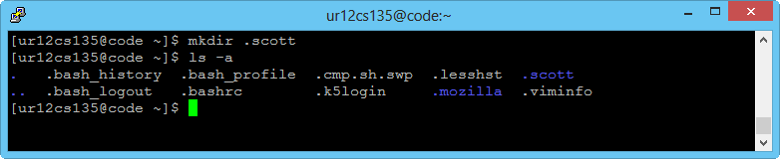
2. Merge two files and store in a new file

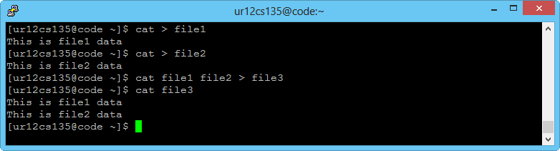

1. Display number of words in a file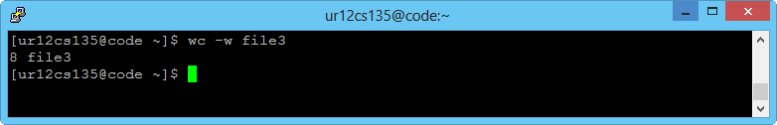
2. Display all files in directory including hidden files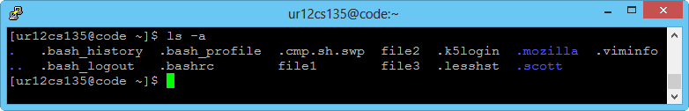
3. Move the newly created files to a new directory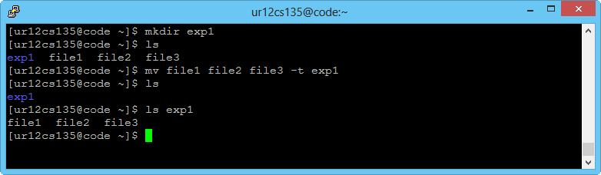
4. Display complete display of files having extension .txt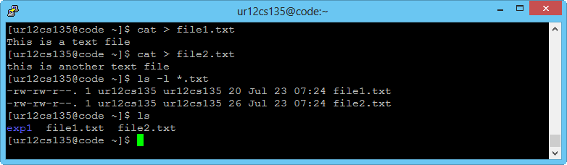
5. Create an empty file with extension of .txt, .cse and .y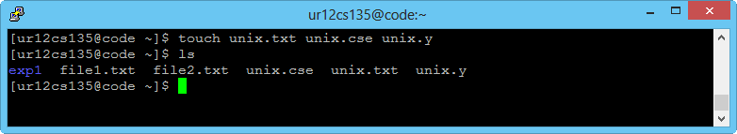
6. Check the number of files available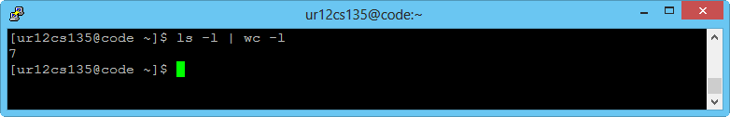
7. Create a file called student with the following content
8. Display students who has CAD as Student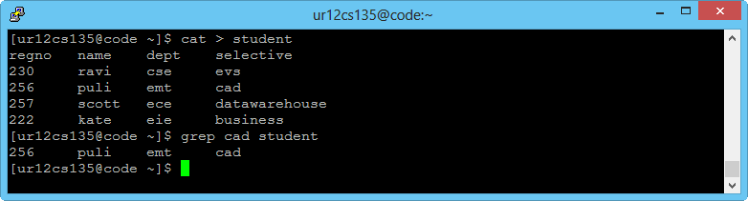
9. Display many of them have name with ‘r’ as starting letting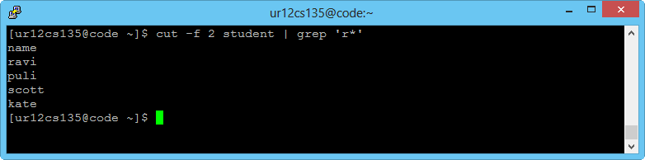
10. Sort list alphabetical order of name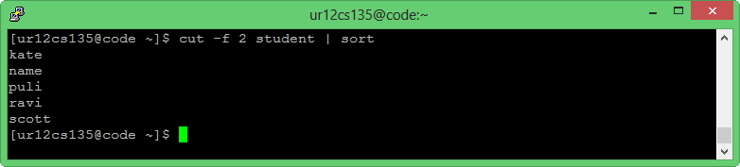
11. Rename file as sudentdetails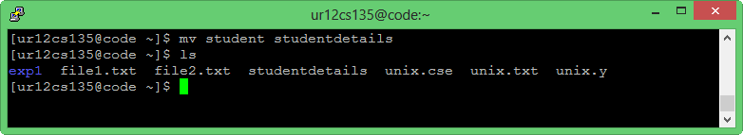
12. Create a backup file for this. (studentbackup)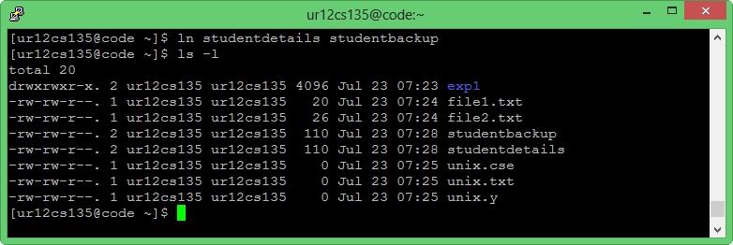
13. List only name and register no of all students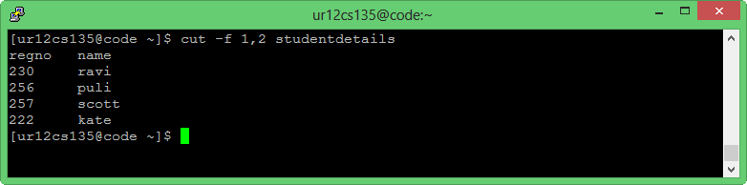
14. How many lines are present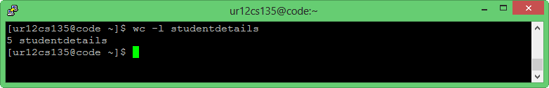
15. Create a directory called ‘y’ and move all files with extension .y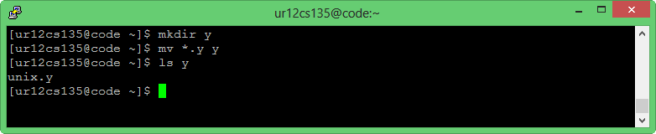
16. Remove above directory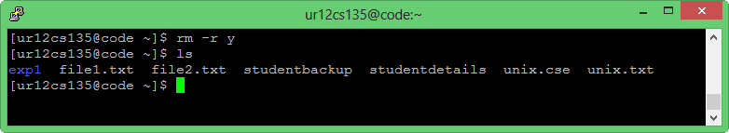
17. Create listed directories in a single line a/b/c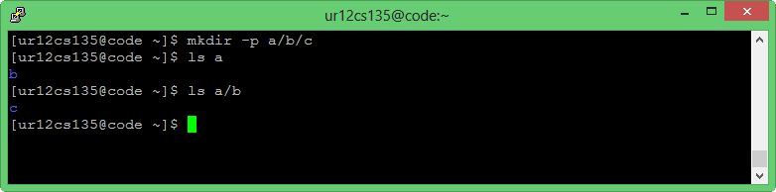
18. Store the user who ever logged into system in a file user.txt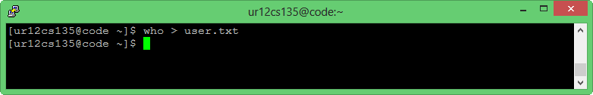
19. Display your birthday by using echo and separate it using cut (dd-mm-yyyy)